Retail Inventory Management System

1. **Creating the tables**

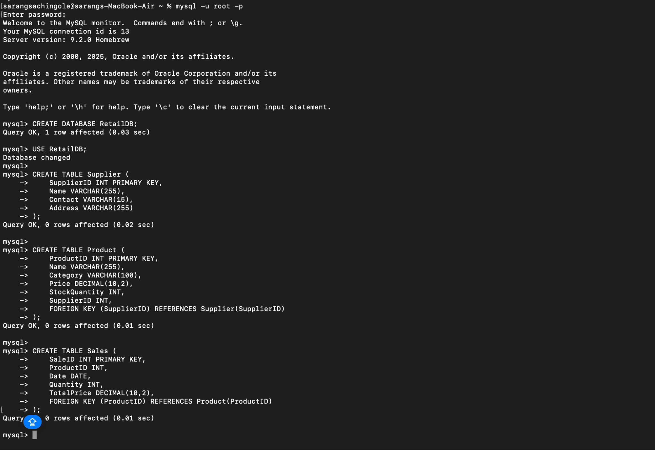

1. **Inserting data Into Table**

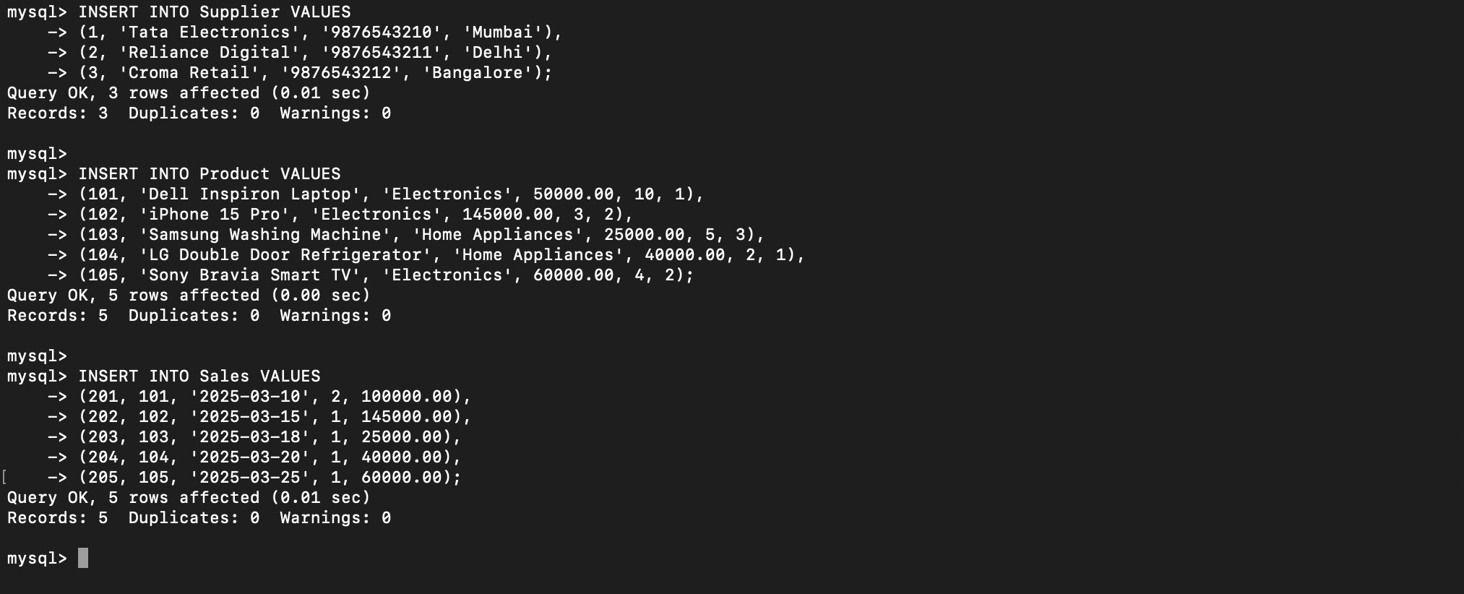

1. **Retrieve products with low stock (less than 5 items remaining)**

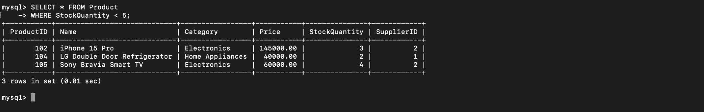

1. **Find the total sales per product**

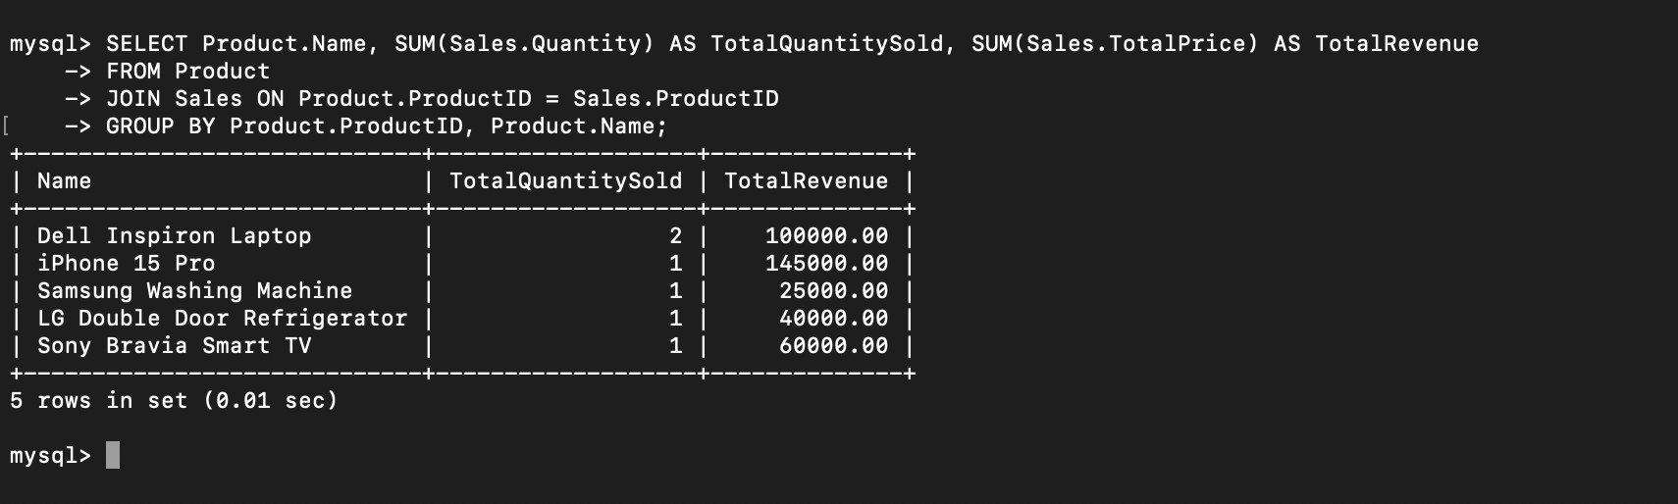

1. **Retrieve the highest revenue-generating product**

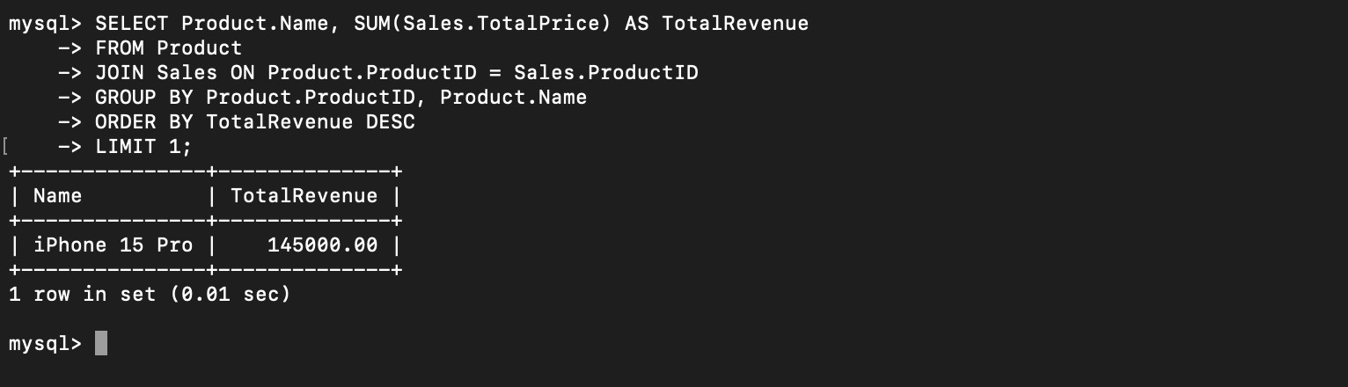

1. **Display products supplied by a specific supplier**

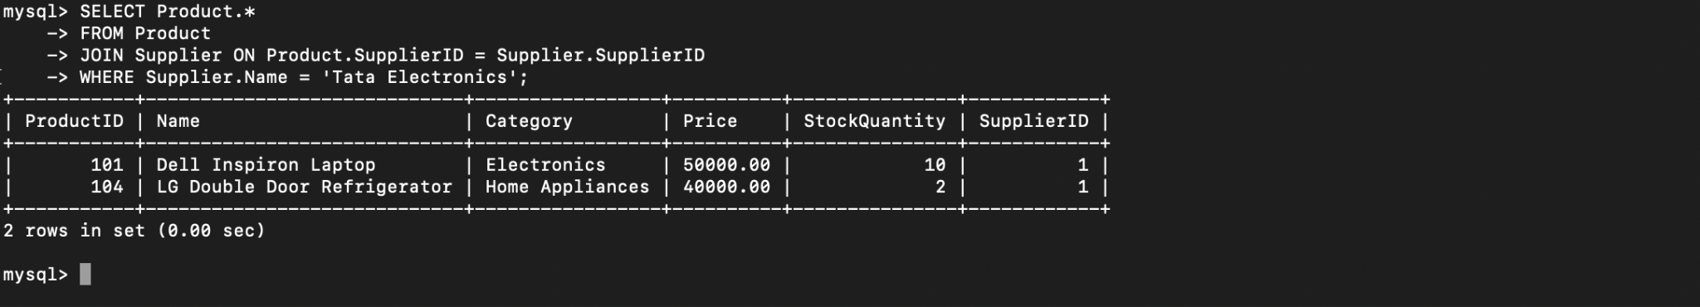

1. **Retrieve all sales made in the last 30 days**

